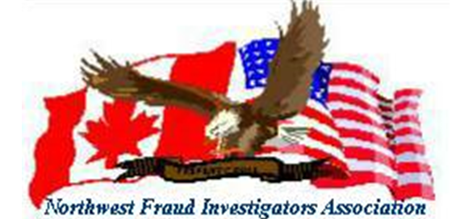
Save The Date
You are cordially invited to attend the Fall 2016 Northwest Fraud Investigators Association’s Conference!
Date: September 28th- September 30th, 2016
Location: Embassy Suites Tigard, Oregon
Hosts: Tigard Police Department & Umpqua Bank
The conference will be two full days with a check in date of September 28th, 2016 at The Embassy Suites.
Special Guest and Keynote Speakers:
Michael J. Bacon former EVP and Chief Security Officer with Wells Fargo and also the founder and managing partner of Rezolvrizk (resolve risk), a risk management firm specializing in assisting companies in resolving their regulatory, security, and employee misconduct risk.
Special Agent Gino, (AG) with the Department of Homeland Security will speak on Bit Coin and the internet underworld.
Steve Winegar former Chief of Police with Tualatin Police Department and currently with Department of Public Safety and Standards and he will speak on Ethics.
T-Mobile will also be there to speak on tools and apps.
Additional booking rate information and schedule to follow – stay tuned in!
***Also we will have our raffle prize drawing to benefit Make-A-Wish, which will include;
T.V.’s, gift cards, Nike items, IFly gift certificate and much more.

