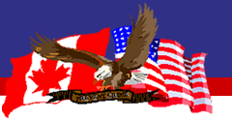

Northwest Fraud Investigators Association – Yes, I/we are a Current on Dues Member, please register me and/or (multiple members from same organization) for the Fall 2016 Conference.

Please fill in & email this registration form to….. [svinyard@redcanoecu.com](mailto:svinyard@redcanoecu.com)

Name(s):

Title(s):

Company Name:

Contact phone(s):

Work email address(s):

If there are any further questions please feel free to contact me.

Sincerely,

Sharon Vinyard, CFE

Northwest Fraud Investigators Association -Treasurer

360-578-5311

If you prefer to send this form in via regular mail to register please mail to:

Sharon Vinyard

C/O Red Canoe Credit Union

PO Box 3020

Longview WA 98632