SAVE THE DATE
You are cordially invited to attend the SPRING 2016 Northwest Fraud Investigators Conference

Date: April 28th – April 30th, 2016
Location: Harrison Hot Springs Resort & Spa in BC, Canada
Topic: TOUCHED BY FRAUD - The far reaching effects of Fraud
Hosts: Staff Sgt Mike DUNCAN, NWFIA President & Cst Tina FOX, Cst Troy PARSONS
-The conference will be held over two full days Friday and Saturday April 29th and 30th, 2016 with check-in at the Harrison Resort on Thursday, April 28th.

Special Guest and Keynote Speaker: Brian Willis, Author, Speaker, Trainer and Winning Mind Training CEO (Chief Excellence Officer)

-Further details to follow with registration and hotel booking information

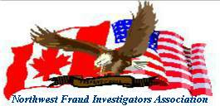
Please visit www.nwfia.org for conference dates/location and Executive Board contacts.

