3VR CrimeDex services provide you with:
- Access to a national database of thousands of known criminals & fraudsters with significant details on their activities and characteristics.
- CrimeCatcher TM: When you add a suspect's image to CrimeDex we use our facial recognition analytics to compare your suspect to all previously uploaded suspects and will notify you if there is a match.
- A nation-wide network of thousands of law-enforcement agencies supporting the fight against fraud and robberies.
- A powerful communication tool that allows investigators to create visual summaries of cases to present to law enforcement and juries.
- A broad information sharing system bringing together thousands of retail and financial institutions and law enforcement agencies
- An innovative alert system that sends out regular, regional alerts to institutions in the CrimeDex® network.
- Link People and Cases: Investigators can identify and investigate links and track fraudsters across the CrimeDex® network.
- Regional Crime Updates: Get regular CrimeDex® updates on criminals and fraudsters targeting your area, and use those updates to search and monitor for related activity across your institutions.
- Customized User Groups: Join or create a CrimeDex user groups for your geographical area or groups consisting of members from existing organizations.
The following page provides instructions for taking advantage of your CrimeDex membership.

How to register for your NWFIA CrimeDex membership:
If you ARE NOT a CrimeDex member already:
Registration to CrimeDex is fast and easy! To join, simply follow the step-by-step instructions below.
- Go to www.crimedex.com
- Click the “Join Now” button.
- Complete the sign-up form:
  - Click the radio button for Group
  - Type “NWFIA” in the box
  - Highlight “NWFIA” in the box when it appears.
  - Click “Select Group”, and then click Next.
  - Follow the rest of the prompts and you will be a new CrimeDex member.
  - After your application is approved, a confirmation will be sent to via e-mail. The approval may take some time; the Moderator of the NWFIA portal must approve your membership.
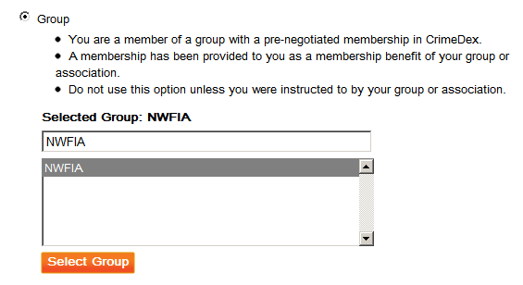
If you Are Already a CrimeDex Member: Send an email to shalverson@redcanoecu.com and you will be invited into the group portal.

Note: If you are using a free email account (like Hotmail, Yahoo, Gmail, etc.) the system will not allow you to “auto join”. Please use a valid company/work email which identifies you as an employee of the company you are signing up with. If you must use one of those type email addresses, send us an email at info@crimedex.com with your phone number and we will contact you directly to help setup your membership.
3VR reserves the right to cancel any individual CrimeDex user's license at any time. CrimeDex users must agree to the terms and conditions listed at https://www.crimedex.com/terms
If you should have any questions or suggestions, please feel free to contact me directly.
Sincerely,
James "Gator" Hudson, Det. Sgt. Ret.
VP CrimeDex Services, 3VR Security, Inc. jhudson@3VR.com, Phone: (415) 874-2523
Already Familiar with CrimeDex? Look what’s new with “CrimeDex 2.0”
In response to the feedback received from our network of CrimeDex members, 3VR has recently launched “CrimeDex 2.0”. With a suite of new features and enhanced user interface, CrimeDex 2.0 takes advantage of the power of Web 2.0 technology to our on-line database of criminal information and e-mail alert system, building an even more powerful tool to fight fraud and criminal activity.
New features included in CrimeDex 2.0:
- CrimeCatcher TM: When you add a suspect's image to CrimeDex we use our facial recognition analytics to compare your suspect to all previously uploaded suspects and will notify you if there is a match.
- CrimeDex “Groups” can have their own private, password protected portal inside the overall CrimeDex community of over 2,000 banks, credit unions, retailers and law enforcement agencies. A Group can be a company or it can be an association. For example we have groups like the Wells Fargo Bank investigators group and the California Financial Crimes Investigators Association. The group portal includes a group Calendar, Discussion Board, and Member Roster. As we go forward, each of these tools will be enhanced as needed.
- As a CrimeDex member, you can join and become a member of multiple Groups. You can also create temporary groups for specific cases (example: The James Gang Task Force Group).
- You can send Alerts to only other Group members, or to States, Regions, or to the entire CrimeDex membership across the US and Canada.
- Note: As of today, if you choose to send the alert to only your group it will only go to other group members directly. However that alert will go into the overall alerts library where other CrimeDex members could search for it and view it. (We are working on implementing a change that keeps a group alert searchable and viewable by group members only unless you mark it for open view by other CrimeDex members).
- Incident-based reporting for multiple crime types makes CrimeDex creates a valuable tool for banks, credit unions and retailers. For example there are “incident templates” for Armed Robbery, Shoplifting, Organized Retail Theft, Check Fraud, Credit Card Fraud and more.
- Receive watch list notifications when data matching an incident you are interested in is entered into CrimeDex.
- Upload video of suspects directly from your 3VR SmartRecorder to CrimeDex for facial comparisons with other suspects and known criminals.
- The i2 visualization tool has expanded capabilities for visualizing data and integrating with i2’s Analyst Notebook, www.i2inc.com.

